Week 11 – Client and Server - HTTPS

A pic here…

**Class:**

**Student numbers:**

**Student names:**

Date: Aug 2019  
Version 1.0

# Setting up the environment

Task1: In order to build and host a website, you firstly must set up your development environment and install specific tools. For the first part of this week assignment you must install all the tools described on the table below:

|  |  |  |
| --- | --- | --- |
| Tool | Purpose | Source |
| Hera server account (Linux hosting) | Fontys Webhosting for students | <https://selfservice.app.fhict.nl/> |
| Visual code | IDE | <https://azureforeducation.microsoft.com/devtools> |
| FileZilla | Transferring your project’s file to the Hera server | <https://filezilla-project.org/> |
| Xampp | Local development environment | <https://www.apachefriends.org/index.html> |

# Create your portfolio.

Task2: Create a portfolio website and add it to your git repository. The requirements for the website are listed below:

1. Home page must be your portfolio.
2. In the about page you must add your contact information.
3. Design the website based on your personality.

Task3: Host your website on the Hera server. Access your website and capture the packet with Wireshark and investigate them. Write all the information that you can gather about the communication between your PC and your Hera server.

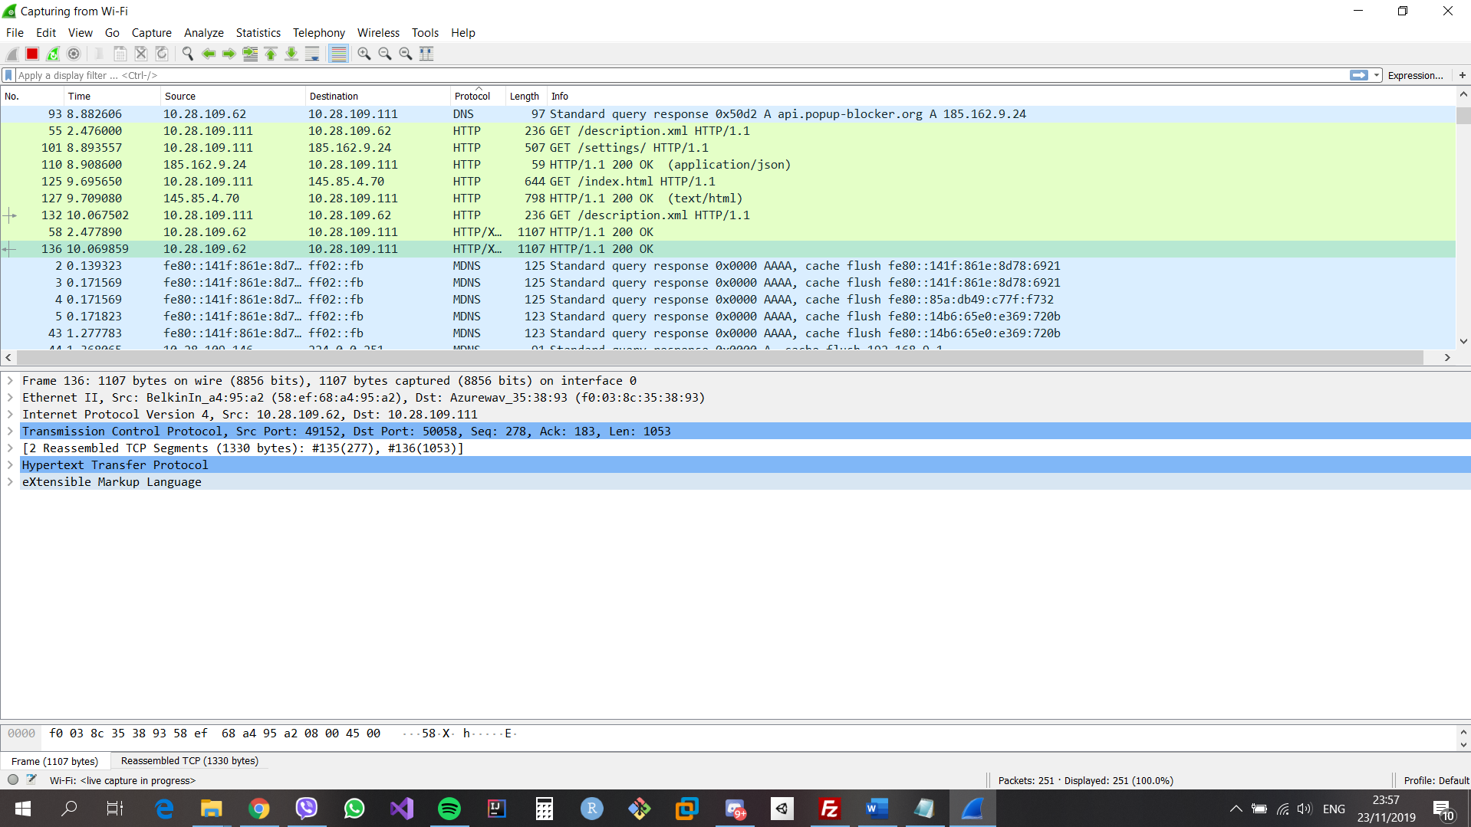

Provide screenshots.

Task 4: Update the readme file of your repository with link to your portfolio website.

### Task5 Optional: Section B

Create a subdomain on Hera server and host another HTML page there with your selected study profile. Add a link from your portfolio to this subdomain.